OFFICIAL COMPANY STAMP
Nested Auto Limited
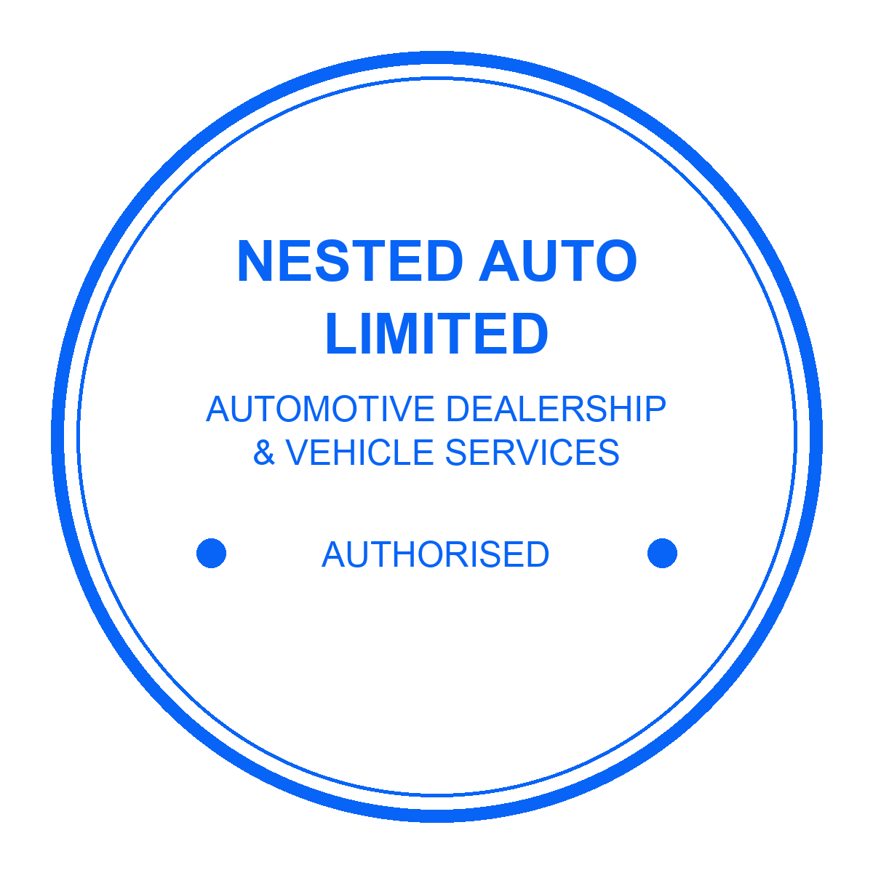
Stamp impression / approval area

